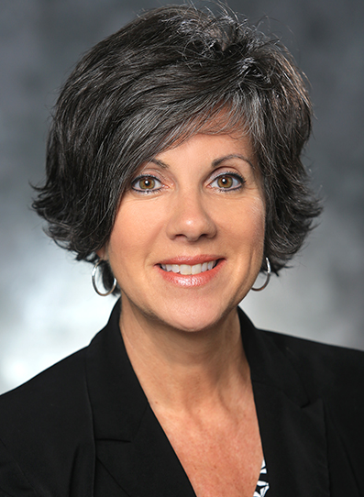
Wendy Evans, Owner,
Security Impact Group, LLC; and
Senior Corporate Investigator,
Lockheed Martin

Wendy Evans, owner of Security Impact Group, LLC, and corporate ethics investigator for Lockheed Martin, graduated in 1987 from Western Kentucky University with a Bachelor of Arts in Broadcast News/Public Affairs and Government Studies. During college and upon graduation, Wendy was a radio news reporter for WBVR, a Clear Channel station in Russellville, Kentucky, and WKCT News in Bowling Green, Kentucky. A career change followed after Wendy was recruited by the Jefferson County (Kentucky) Police Department in 1989. As a patrol officer, she was a certified first responder. In 1992, she was promoted to public information officer (PIO) and assistant to the chief of police. In 1997, she became a special agent with the Federal Bureau of Investigation (FBI) and successfully completed a 16-week academy in Quantico, Virginia. She was assigned to the Orlando Resident Agency of the Tampa Division. As an FBI agent, Wendy served as special Agent on the White Collar Crime Squad and the Foreign Counterintelligence Squad. Wendy briefly left law enforcement to care for her growing family; however, she became certified through the State of Florida as an insurance Investigator, and she worked for Specialized Medical Investigations (SMI). In February 2006, she became a security manager for Lockheed Martin Missiles and Fire Control, where she managed internal investigations for the MFC Enterprise. She also prepared and delivered counterintelligence briefings for the company. Wendy joined Simulation Training and Support as ethics officer in 2010. She became a senior security manager for Global Training and Logistics in 2011 and returned as senior ethics officer for Mission Systems and Training in 2014. She has been serving as senior corporate investigator since 2015.

